Top Nylon Extruded Rods Manufacturers in India : Why Polestar Polymers India Leads the Industry
When it comes to choosing the right engineering plastic materials, nylon extruded rods have become a go-to solution for countless industries across India. From automotive and electrical to textile machinery and industrial engineering, nylon rods offer unmatched durability, machinability, and performance.
But here’s the real challenge - finding dependable Nylon Extruded Rods Manufacturers in India who can guarantee consistency, strength, and top-grade materials every single time.
If you're searching for reliability, quality, and long-term value, one name consistently stands out: Polestar Polymers India.
In this blog, we’ll dive deep into:
✔ What nylon extruded rods are
✔ Why they're indispensable in modern industries
✔ What separates excellent manufacturers from average ones
✔ And why Polestar Polymers India has become a preferred choice for businesses across the country
Whether you’re a procurement manager, machinery manufacturer, dealer, or engineer - this guide will help you make a confident, informed decision.
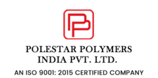

What Are Nylon Extruded Rods?
Nylon extruded rods are solid cylindrical rods made using the extrusion process. They are known for their exceptional:
- Mechanical strength
- Wear resistance
- Chemical stability
- Low friction properties
- Dimensional accuracy
- Long service lifespan
Because of these characteristics, nylon rods are used to make bushings, rollers, gears, pulleys, spacers, and hundreds of other components used across industries.
Simply put: Nylon rods help machines run smoother, longer, and more efficiently - without frequent maintenance.
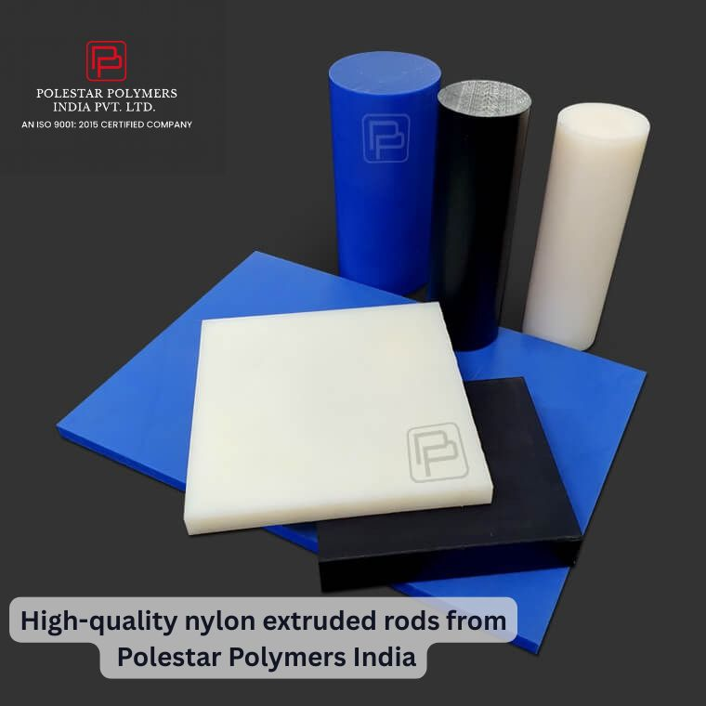

Why Industries Prefer Nylon Extruded Rods Over Metal
A major reason behind the rising demand for nylon rods is that they replace metals in many applications. Here's why:

1. Lightweight Yet Strong
Nylon weighs far less than metal but still offers comparable strength.

2. Corrosion-Free
Zero rusting, zero degradation—perfect for harsh environments.

3. High Wear Resistance
Ideal for moving or sliding components.

4. Easy to Machine
Reduces production time and machining costs.

5. Cost-Effective
Lower material cost + long service life = high ROI.
This shift towards lightweight engineering materials has created a real need for reliable Nylon Extruded Rods manufacturers in India.
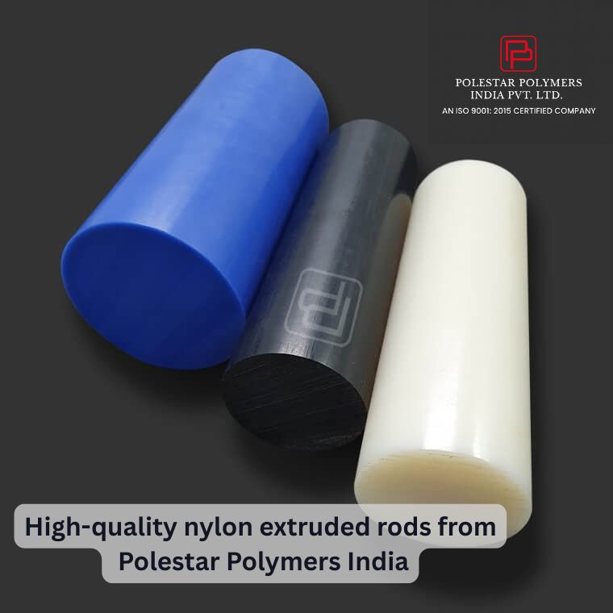

What Makes a Good Nylon Extruded Rod Manufacturer?
Before choosing a supplier, here’s what you should look for:

1. Material Quality
A trustworthy manufacturer uses premium-grade raw materials that guarantee durability.

2. Production Standards
Modern extrusion technology ensures consistency—especially in diameter, density, and finish.

3. Availability & Range
From standard rods to custom sizes, your manufacturer must meet your project needs.

4. Technical Support
Guidance on grade selection, machining properties, and application suitability is essential.

5. Industry Experience
An experienced manufacturer understands real-world application challenges.
And this is where Polestar Polymers India shines.
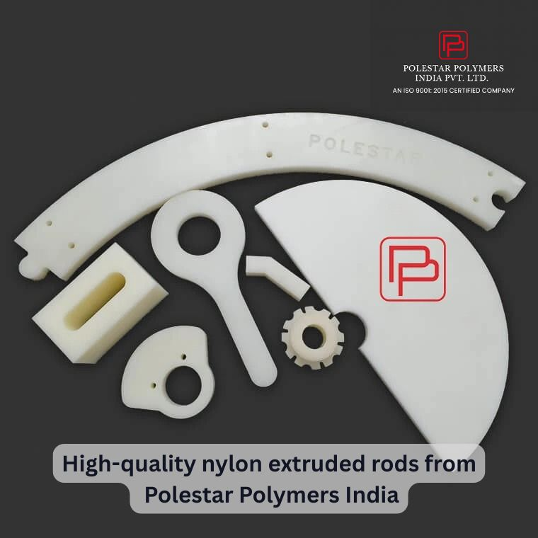

⭐ Polestar Polymers India: One of the Leading Nylon Extruded Rods Manufacturers in India
Over the years, Polestar Polymers India has emerged as a trusted name in the engineering plastics market. The company has built a strong reputation for delivering world-class nylon cast and extruded products with unmatched consistency.
If you're looking for a supplier who prioritizes performance, precision, and long-term reliability - this is the brand you should know.
👉 View product details: https://polestarpolymers.com/nylon-cast.html

Why Polestar Polymers India Stands Out
Let’s break down what makes Polestar a preferred supplier for thousands of businesses.

1. Premium-Grade Nylon Material
Polestar uses high-quality raw materials to ensure:
- Superior strength
- Perfect machinability
- Heat and chemical resistance
- Smooth surface finish
This leads to longer-lasting parts and better machine performance.

2. Advanced Manufacturing Technology
Their extrusion systems deliver rods with:
- Consistent diameter
- Uniform density
- Zero bubbles or impurities
- Perfect structural stability
This precision is essential for machined components that demand accuracy.

3. Wide Range of Sizes & Custom Options
Whether you need standard sizes or custom diameters, Polestar offers:
- Multiple rod diameters
- Various colors
- Custom lengths
- Special-grade materials
Their flexibility makes them suitable for small workshops as well as large industries.

4. Expert Guidance for Industrial Applications
With years of experience, the Polestar technical team helps customers select:
- The right nylon grade
- The optimal rod size
- The best application match
This support ensures your product lasts longer and performs better.

5. Strong Customer Trust Across India
Polestar supplies nylon extruded rods to industries such as:
- Automotive
- Textile machinery
- Packaging equipment
- Electrical & electronics
- Industrial engineering
- Food processing
- Chemical industries
Their nationwide customer base shows the brand’s reliability and acceptance.
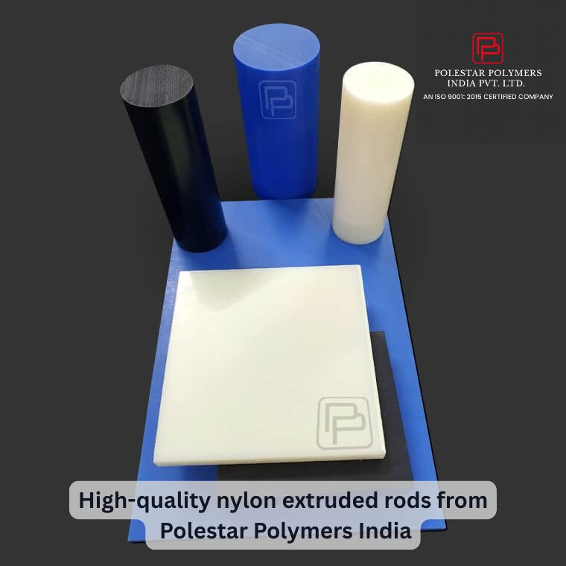

Where Are Nylon Extruded Rods Used? (Industry Applications)
Thanks to Polestar’s quality and precision, their nylon rods are widely used for manufacturing:
- Gears
- Bushings
- Rollers
- Wear pads
- Insulation components
- Guides
- Pulleys
- Machine parts
- Spacers
- Marine components
If your machinery requires friction resistance, noise reduction, or lightweight materials—nylon rods are the perfect fit.

Why Choosing the Right Manufacturer Matters
Not all nylon rods on the market are equal. Low-quality rods can cause:
- Cracking during machining
- Inconsistent dimensions
- Premature failure
- Operational breakdowns
- Increased maintenance cost
When you're running industrial machinery, these issues lead to downtime and heavy losses.
By choosing Polestar Polymers India, you ensure:
✔ Long-lasting performance
✔ Reduced maintenance
✔ Smooth operation
✔ Better machining output
✔ High ROI
And that’s exactly why companies across India trust Polestar.

Why Polestar Polymers India Should Be Your Go-To Supplier
Let’s summarise why Polestar is the right pick:
✔ High-quality nylon extruded rods
✔ Reliable manufacturing standards
✔ Wide size range
✔ Custom solutions
✔ Strong industrial trust
✔ Consistent quality assurance
✔ Affordable pricing
✔ Fast delivery
Whether you're a manufacturer, dealer, wholesaler, or industrial buyer—Polestar offers the reliability you need.

Looking for Nylon Extruded Rods Manufacturers in India? Choose Polestar Polymers India
If you want nylon rods that truly deliver performance, durability, and value, Polestar Polymers India is a name you can trust.
👉 Explore product details here: https://polestarpolymers.com/nylon-cast.html
Their nylon extruded rods are engineered to meet the strictest industrial standards—making them a perfect choice for any application requiring strength, stability, and precision.
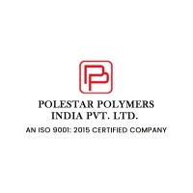

Final Thoughts
As industries evolve and demand high-performance engineering materials, nylon extruded rods continue to rise in popularity. However, choosing the right manufacturer makes all the difference.
With its top-grade products, modern manufacturing capabilities, and customer-first philosophy, Polestar Polymers India truly stands among the best Nylon Extruded Rods manufacturers in India.
If quality, durability, and long-term reliability matter to you—Polestar should be your first choice.
👉 Explore details here: https://polestarpolymers.com

